# Annotation Guidelines

This document explains the gold standard annotations for training and evaluating NLP systems to extract medical problem information from clinical narratives. The clinical narratives may be pre-annotated for drug and symptom information. The phenomena of interest are annotated as events, where each event is represented by a trigger and set of arguments. The trigger consists of a multi-word span (word or phrase) and a label indicating the event type (e.g. drug, problem). Figure 1 is an example of a problem event from the BRAT annotation tool, which will be used in this annotation project. In Figure 1, the trigger span is “headache” and the trigger label is *Problem*. This *Problem* event is characterized by an *Assertion* argument, consisting of the multi-word span “reports” and a label indicating the medical problem is *present*. The event also includes the *Duration* span “since last week.” All annotated phenomena are defined in terms of the span (words associated with phenomena) and the span type (e.g. *Assertion* or *Duration*). Some annotated phenomena, like *Assertion*, will also include a span label (e.g. *present* or *absent*).

**Figure 1. Annotation example for a Problem event**

The annotated events include (*indicates mandatory attributes, *italic* indicates arguments with both spans and labels):

* Drug **(Pre-annotated)**
  + Drug name (trigger)*
* Medical Problem **(Partially Pre-annotated)**
  + Medical problem name (trigger)*
  + Assertion* (labels: present, absent, possible, conditional, hypothetical, not_patient)
  + Change (labels: no_change, worsened, improved, resolved)
  + Severity (labels: mild, moderate, severe)
  + Anatomy
  + Characteristics
  + Duration
  + Frequency

The relationship between Drug and Medical Problem events is captured through Drug-Problem interactions and Problem-Problem interactions:

* Relationship between Drug and Medical Problem
  + Drug causes Problem (causes)
  + Drug improves Problem (improves)
  + Drug worsens Problem (worsens)
  + Drug administered for Problem (admin_for)
  + Drug not administered because of Problem (not_admin_because)
* Relationship between two Medical Problems
  + Problem indicates medical problem (PIP)

# Definition of annotated phenomena

The following subsections describe how the medical problem event and relationship will be annotated. For the medical problem event, some arguments should always be present and are required. However, some arguments will not always be present. Required arguments are indicated.

## (0) Drug (Pre-annotated)

**(1) Drug Triggers (Required):** This event type should be selected to specify a drug. The Drug Entity Tag type should include classes of drugs, as well. However, illicit drugs and alcohol should not be annotated.

* The trigger should be the shortest span possible.
* Please review Possible_Drug spans by correcting/deleting/adding new Possbible_Drug spans.
* Rule of thumb for formats two drugs mentioned together, such as “*Drug A/Drug B*”, “*Drug A (Drug B)”,* …
  + **One span**: they belongs to the same drug type, or one is a subset of another
  + **Two separate spans**: different drug types, as alternative treatment plans; or both drug types are needed for treatment



|  |
| --- |
| **Examples:**  Patient is experiencing muscle pain, secondary to statin therapy for coronary artery disease.  The patient suffers from steroid-induced hyperglycemia.  Patient prescribed 1 x 20 mg Prednisone tablet daily for 5 days.  Patient has been switched to lisinopril tablet 10mg 1 tablet PO QD.  Patient received 100 Units/kg IV heparin sodium injection for treatment of deep vein thrombosis.  Sulfa (sulfonamide antibiotics)  Tylenol (Acetaminophen) B.i.d. (twice a day) |

## (1) MEdical Problems

**(1) Problem Triggers (Required):** phrases that contain observations made by patients or clinicians about the patient’s body or mind that are thought to be abnormal or caused by a disease. They are loosely based on the UMLS semantic types of pathologic functions, disease, or syndrome, mental or behavioral dysfunction, cell or molecular dysfunction, congenital abnormality, acquired abnormality, injury or poisoning, anatomic abnormality, neoplastic process, virus/bacterium, sign or symptom, but are not limited by UMLS coverage. Generally, the trigger span should not include anatomical information or characteristics of the problem, as this information is captured through separate *Anatomy* and *Characteristics* arguments. The trigger span should be the shortest span possible.

What should be annotated?

* Medical problems need to be things that are wrong with the patient and can be treated.
* They need to be able to be modified with a negation modifier.
* They need to belong to one of the above semantic types, but do not need to be UMLS concepts.

All three of these conditions must hold. A list of semantic categories is provided in the table below.

**Table 1: Semantic types of medical problem events. The problem triggers are in blue**

|  |  |
| --- | --- |
| **Semantic categories** | **Examples** |
| **Phrases that name a disease, syndrome, sign, or symptom**  What was treated? anxiety. (can also be negated: “no anxiety”)  Question test: What was treated? wound.  Question test: What was treated? serous drainage.  Question test: What was treated? clean? -> does not fit the definition of something being wrong with the patient. | * Ativan 0.25 to 0.5 mg IV q 4 to 6 hours prn anxiety. * the wound was noted to be clean with mild serous drainage. * Blood on his underwear, discussed <DATE/>. * An echocardiogram revealed a pericardial effusion and possible tamponade clinically. * The drop in hematocrit was secondary to … * PP Test: can be rearranged to the hematocrit drop. * The patient has had increasing dyspnea on exertion. * He underwent a resection of a skull base chordoma. * Neurologic Symptoms: Headaches, Lethargic. * Tried omeprazole for 3 days, but it gave him a stomach ache and dry heaves. * Transfusion thresholds: Hct<26%, Plts < 20K (hematuria / epistaxis). * The patient 's respiratory status continued to decline. * PET scan given Lynch, prior colon cancer and newly elevated CEA. * but consistent with hypersensitivity such as a drug eruption, urticaria or if applicable insect bite reaction. * She is here today to check her counts, as she continues on valganciclovir for treatment of her CMV antigenemia. * Numerous hypermetabolic foci of lymphomatous involvement most of them demonstrating central necrosis are present within … * Patient previously on Levofloxacin (<DATE/>-<DATE/>) for possible PNA. Please see Pulm below. |
| **Mental or behavioral status observations** | His mental status changes remained stable.  The patient developed a sudden change in her mental status.  PP test: a sudden mental status change.  She did well except for some episodes of confusion.  The patient seemed subdued.  The patient was unresponsive. |
| **Viruses and bacteria** | Blood cultures were positive for S. Veridans.  Procured sample to rule out MRSA.  CMV Serology: Donor negative, Recipient positive.  Hx of E. coli bacteremia: IV antibiotics thru <DATE/>.  This is similar to early symptoms he had in the hospital associated with his BK viuria.  HCV, HBV, negative; |
| **Injury** | Patient arrived with a broken arm.  Examined the deep gash in her head.  Patient has arm pain. |
| **Abnormalities** | The defects were found.  chest x-ray revealed an abnormality.  Hx benign cystic tumor of pancreas.  Hx thyroid nodules. |
| **Test results explicitly stated to be abnormal** | moderately decreased ejection fraction.  Pt had mildly low blood pressure.  The patient presents with his third temperature spike in approximately 48 hours.  Cardiovascular: Irregularly irregular rhythm  Continue holding losartan as patient is currently hypotensive/normotensive |

**Wrong example**: Problem trigger outside the guideline definition.

-> the first Polypharmacy is the header without assertion values. The confusion is not a medical problem. Correct annotation - Only label the Polypharmacy as below:



**Correct example**: Polypharmacy does not have an explicit assertion, but its treatment plan is included below.

Polypharmacy: __

Can be treatment by,…, …

**Note**: Problemshould **not** include measured phenomena and laboratory results, like temperature (e.g. “temperature of 100°F”), blood pressure (e.g. “BP 120/60”), and heart rate (e.g. “HR 112”); however, *Problem* **may** include signs/symptoms related to these measurements, for example “fever.” *Problem* should not include normal states, like “feeling well.” Examples of concepts that should **not be marked (in Red)** as Medical Problems are listed below.

a) Statements about normal states of health

* she had been comfortable on the Morphine drip
* wound was clean
* He was dynamically stable on his Dobutamine
* converted back to normal sinus rhythm
* serum uric acid was normal

b) Physiologic measurements, vital signs, or the tests that measure them and statements of bodily function (even if the value of the test could be inferred to be outside normal range)

* EF 35%
* Blood pressure 145/95
* will monitor BUN / Cr after giving Lasix

c) Verbs that describe the outcome of an event

* the patient defervesced
* the tumor was growing
* the patient 's respiratory status continued to decline
* the patient 's LDH climbed

d) Alcohol, elicit drug, and tobacco use

* 2 packs cigarettes per day
* moderate alcohol use
* he uses recreational drugs

e) Section headers that are included in the clinical procedure or note template, but have no implications about the patient’s health status

* Pain assessment: Include pt's pain assessment.

More *Trigger* annotation examples are presented in Table A in the appendix.

Separate *Trigger* spans (separate events) should be created for each problem, even if the problems are presented in a list. Figure 2 is a BRAT annotation example, where three symptoms, “TB,” “hepatitis,” and “HIV,” are listed together. Each symptom is a distinct *Trigger*, forming three separate events. In general, the trigger spans will not include commas or the word “and.”

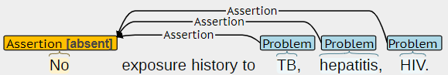

**Figure 2. Problem BRAT annotation example with a list of Problems.**

**Problem span adjacent to Anatomy. Because *dilation* itself is not a problem, so we annotate *ductal dilation* together.**

**Similar examples below (correct):**

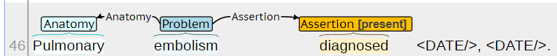

**(2) Assertion (required):** *Assertion* indicates whether the note asserts the problem for the patient, which is required for the Problem Trigger to make sense. *Assertion* annotation includes both a span and label: *present*, *absent*, *possible*, *conditional*, *hypothetical*, or *not_patient*. *Assertion* is time independent (no differentiation between current and past). For present problems, there may be a verb that indicates the *present* label (e.g. "admits," "reports," or "has"); however, the *present* label may be implicit, due to the lack of cues indicating *absent*, *possible*, etc. The *Problem* trigger span may be annotated as *Assertion*, if there is not a specific phrase indicating the *present* label. Table 2 presents several *Assertion* annotation examples. Below is a brief description of each label:

* *present*: patient experienced or is experiencing
* *absent*: patient has not or is not experiencing
* *possible*: patient may be experiencing (denoted by terms like “probably” or “likely”)
* *conditional*: patient only experiences under specific conditions
* *hypothetical*: patient may experience in the future
* *not_patient*: not associated with the patient

**Table 2. Problem Assertion annotation examples. Underlined words indicate the identified span.**

|  |  |
| --- | --- |
| **Label** | **Examples** |
| present | Patient admits cough.  HPI: <AGE/> yo with hx HTN, AF with RVR who p/w nausea and dizziness.  HPI: the patient had 1 week history of fever/chills, upper respiratory symptoms.  The patient had fever, cough, SOB x 3 days prior to admission.  Patient reports chronic cough, non-productive.  CT AB/PEL <DATE/> due to abdominal pain.  Today, the patient states the edema is improving on its own.  Levaquin - Rash. |
| absent | No vomiting, fever.  Denies nausea, vomiting, diarrhea, constipation, abdominal pain, or changes in bowel habits.  - Non-neutropenic fever/rigors (<DATE/>): Resolved. |
| possible | … likely secondary to viral URI/ possible flu-like symptoms with myalgias.  … likely secondary to viral URI/ possible flu-like symptoms with myalgias.  … running the risk of worsening and possibly long-term neuropathy.  ABDOMEN: Protuberant, soft, nontender, questionable ascites.  Because of indetermined disease status, anastrozole 1 mg daily was prescribed. |
| conditional | He does become slightly short of breath when lifting furniture.  PULMONARY: +Chronic cough x 4 years. Noticed after eating. Varies in severity.  Mr. <PATIENT/> also has bilateral hip pain if he is on his feet for any length of time.  Allergies: Dexamethasone – Balance Issues.  Respiratory: SOB (with exertion), cough, … |
| hypothetical | If you have fever, please contact your PCP or return to the emergency room.  Fever may result from medications.  Benadryl 2% cream 3 times daily as needed for itching.  baclofen 10 mg oral tablet Dose: 5-10 mg PO TID PRN Hiccups.  After transplant, prophylaxis - Drug XX to prevent infection. (*future condition*.) |
| not_patient | His grandmother, who also cares for him, recently had a cough…  Mother died at <AGE/> from aortic aneurysm.  Family history: negative for cancer. (*beyond the guideline*) |

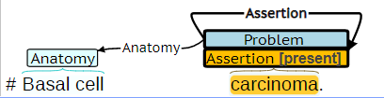

**Figure 3. Assertion BRAT annotation example where Assertion and Problem spans overlap.**

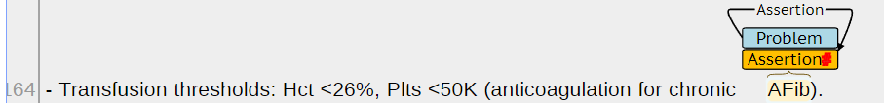

Example Assertion MISSING value. Should be corrected to:

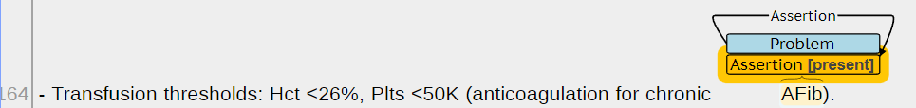

**(3) Change (optional):** *Change* annotation captures **explicit** descriptions of changes in the state of the problem. *Change* annotation consists of a span and label: *no_change*, *improved*, *worsened*, and *resolved*. Table 3 presents several *Change* annotation examples.

**Table 3. Problem Change annotation examples. Underlined words indicate the identified span.**

|  |  |
| --- | --- |
| **Label** | **Examples** |
| no_change | He had no change in shortness of breath.  His mental status changes remained stable  Chronic AFib: rate controlled & stable on bisoprolol and propafenone. Anticoagulated with Xarelto.  He has a history of left gynecomastia, has been sensitive for many years. There are no changes.  <NAME/> has persistent L upper posterior. |
| improved | Cough - Chest congestion, cough improving.  Patient reports that his pain is currently under control. |
| worsened | Presented to ED today with worsening shortness of breath, pleuritic chest pain and …  She had a flare in pain.  He had a progressive pain. |
| resolved | Back pain resolved after PT.  He says that … and the pain in this right thigh went away.  Neutropenia on arrival; now resolved after G-CSF x1 on <DATE/>. |

**(4) Severity (optional):** *Severity* indicates the severity or intensity of the problem. *Severity* annotation consists of span and label: *mild*, *moderate*, or *severe*. If the description of the problem includes qualitative descriptions, like “slight,” “mild,” or “extreme,” the *Severity* label should be determined based on these explicit *Severity* descriptions. If such qualitative descriptions are absent, the *Severity* label may be implicitly determined based on available descriptions of the treatment of the problem. Treatment should only be used to assess *Severity* where the treatment is related to the problem. Table 4 presents annotation examples for both *Severity* cases (qualitative description vs. treatment).

**Table 4. Problem Severity examples. Underlined words indicate the identified span.**

|  |  |  |
| --- | --- | --- |
| **Priority** | **Label** | **Examples** |
| 1. Explicit  (severity described) | mild | He has mild cough. |
| moderate | Pt c/o of generalized moderate pain and stiffness x 1 today. |
| severe | Patient reports severe back pain.  Pt has a high fever. |
| 2. Implicit  (treatment described) | mild  (no treatment need) | Patient has been experiencing chest pain for the past two weeks, not requiring any pain medications. |
| moderate  (treatment needed) | Fevers - ibuprofen and tylenol.  <AGE/> y/o man day 27 s/p MURD PBSCT for refractory CLL.  Orthostasis. Patient will receive 1L NS IVF in triage today.  Added topical triamcinolone -> <DATE/> rash is very faint c/w good response. |
| severe  (hospitalization needed) | Patient experiences breathing difficulties that require ventilation. |

**(5) Anatomy (optional):** *Anatomy* indicates the body part or region of the body associated with the problem. *Anatomy* annotation only includes a span. The selected span should include the most specific description of the body part/location available. For example, “chest wall” should be annotated over just “chest,” or “RUQ abdominal” should be annotated over “abdominal.” Table 5 presents annotation examples for *Anatomy* spans. A single event (trigger) may have multiple *Anatomy* spans. For example, pain could be located in both the “neck” and “back.”

**Table 5. Problem Anatomy examples. Underlined words indicate the identified span.**

|  |
| --- |
| **Examples** |
| … pain on the chest wall.  (+) Per HPI and wet productive cough for two days and a new band like pain in lower chest since yesterday  …pt cont to have pain in the lower back…  …who presented to [**Hospital1 2**] ED with chronic chest pain …  …35M with Cerebral palsy, presented with abdominal pain and…  Patient … found to be progressively more jaundiced and with RUQ abdominal pain.  Patient …. associated with a bladder abnormality.  His presumed viral upper respiratory infection has resolved.  He did have some peripheral neuropathy related to his chemotherapy for testicular cancer.  Heparin was restarted because of a possible small dissection in the RCA. |

**More anatomy spans:**

* Follicular,
* Embryonal,
* B-cell,
* Nodal,
* Posterior superior margin of the proximal body of the pancreas.
* Muscle
* Osseous

**(6) Characteristics (optional):** *Characteristics* are problem descriptors, including descriptions of color, consistency, sound, pain, diffuse/localized, etc. Characteristics annotation only includes a span. Table 6 presents annotation examples for *Characteristics* spans. A single *Characteristics* span may include a single descriptor, like “productive,” or multiple descriptors, like “wet productive,” if descriptors are presented in a continuous word sequence. A single event (trigger) may have multiple *Characteristics* spans. For example, a cough could be described through two *Characteristics* spans, like “dry non-productive” and “painful.”

**Table 6. Problem Characteristics examples. Underlined words indicate the identified span.**

|  |
| --- |
| **Examples** |
| (+) Per HPI and wet productive cough for two days and a new band like pain in lower chest since yesterday.  Patient has had chronic dry cough but has experienced clear sputum production since yesterday.  next c/o [**10-16**] headache stabbing pain, typical of her migraine pain.  (+) Per HPI, also has intermittent headaches, diffuse muscle aches, nausea.  dry non-productive cough (Guifenesin w/codeine q6h prn), painful for pt as stated …  (+) Per HPI, he also endorses yellow-white productive sputum, SOB, wheezing, …  His presumed viral upper respiratory infection has resolved.  Abnormal weight loss.  He states he previously had sharp, *intermittent* pains lasting ~10 sec …  The patient has diffuse tumor with …  Severe coronary artery disease with multiple stents followed by Dr. <DOCTER/>.  <PATIENT/> reports some improvement in his sudden onset of nausea, vomiting, especially with eating.  a history of noninsulin dependent diabetes mellitus, now presenting with acute blurry vision on the left side.  Hx benign cystic tumor of pancreas.  No progression of lytic areas which are consistent with diffuse metastatic involvement of disease |

**Example Characteristics:**



**Characteristics don’t overlap with other attributes, except assertion. The span *stable* should only be annotated once.**

**(7) Duration (optional):** *Duration* describes how long a problem has persisted or when the problem started. *Duration* annotation only includes a span. Table 7 presents annotation examples for *Duration* spans. *Duration* spans will often be a prepositional phrase or adverb phrase, in which case the entire phrase should be selected. A single event (trigger) may have multiple *Duration* spans.

**Table 7. Problem Duration examples. Underlined words indicate the identified span.**

|  |
| --- |
| **Examples** |
| Patient reports headache since last week.  hpi: the patient had 1 week history of fever/chills, upper respiratory symptoms.  The patient had fever, cough, SOB x 3 days prior to admission.  (+) Per HPI and wet productive cough for two days and a new band like pain in lower chest since yesterday  68 y/o gentleman with acute on chronic fatigue and SOB…  He experienced a sudden exacerbation of his LBP after lifting a tree onto top of car.  Palpitions and increased HR with exertion and sometimes when resting since transplant.  He reports one episode of a few dry heaves; following which, he feels better.  Although she was known on <DATE/>, to have new adenopathy as well as evidence of disease within the liver. (similar too “new-onset”, “not new”,)  **Negative example**  Mrs. <PATIENT/> is seen for report of fever 101F at home this afternoon, on retake it was 100.5. Upon arrival to Triage it was 37.9C. - –(this afternoon is just one point of time, not duration.) |

**(8) Frequency (optional):** *Frequency* describes how often a problem occurs (e.g. occasionally, intermittently, chronic, daily, hourly, persistent, etc.). *Frequency* annotation only includes a span. Table 8 presents annotation examples for *Frequency* spans. A single event (trigger) may have multiple *Frequency* spans.

**Table 8. Problem Frequency examples. Underlined words indicate the identified span.**

|  |
| --- |
| **Examples** |
| (+) Per HPI, also reports occasional HA and back pain, and ? some recent wt gain, endorses occ DOE.  (+) Per HPI, also has intermittent headaches, diffuse muscle aches, nausea.  68 y/o gentleman with acute on chronic fatigue and SOB…  Stable longstanding joint pains.  the patient had severe nausea. It happened every 2 hours.  He does have constant pain in his pelvic area which has not been relieved by his oxycodone.  She complains of frequent headaches/”heaviness”/dizziness. |

**BRAT examples:** Figure 4 **-** Figure 8 are BRAT annotation examples for problem events. Figure 4 presents annotations for a problem event for which the Assertion is absent. Figure 5 includes multiple problem events with shared Assertion and Duration spans. Figure 5 also includes a Trigger span, “respiratory symptoms,” that overlaps with the Anatomy span, “upper respiratory.” Figure 6 includes annotations for *Assertion*, *Frequency*, *Characteristics*, and *Duration*. Figure 7 presents annotations for a sentence with multiple *Trigger* and *Assertion* spans, including an *Assertion* span shared by three events. Figure 8 presents an annotation example with multiple *Anatomy* spans.

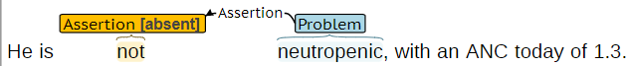

**Figure 4. Problem example where *Assertion* is *absent***

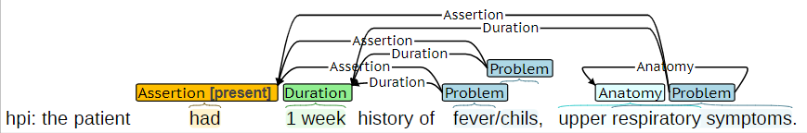

**Figure 5. Annotation example where the problem *Trigger* span, “respiratory symptoms,” overlaps with the *Anatomy* span, “upper respiratory.”**



**Figure 6. Annotation example with *Assertion*, *Frequency*, *Characteristics*, and *Duration* annotations.**



**Figure 7. Annotation example with multiple problem *Triggers* and multiple *Assertion* spans, including a shared *Assertion* span.**

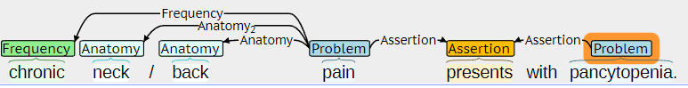

**Figure 8. Annotation example with multiple *Anatomy* spans**

## (2) Relations between Problems and Drug events:

Annotated *Drug* and *Problem* event triggers could be related in different ways as described in the table below. Phrases that indicate a relation between the *Problem* and *Drug* are not annotated.

Relations within the same sentence are more important than cross-sentence relations.

Problem-drug relations needs to be annotated for all problem-assertion values, even with Assertion-absent.

Table 9. Text in blue and red indicates the annotated problem and drug triggers

|  |  |
| --- | --- |
| Relation | Examples |
| **a. Drug improves Problem (*improves / not worsening*).** This includes mentions where the  treatment improves, cures, stablize the problem. | * hypertension was controlled on hydrochlorothiazide * She has an elevated cholesterol controlled with Zocor * infection resolved with antibiotic course * Type 2 DM, controlled/managed on Meformin 500 mg BID. * .Idiopathic thrombocytopenic purpura responsive to prednisone, however, with a short-lived response, which has failed with a prednisone taper. * Hypokalemia: Nicely resolving. Plan, to have her reduce her potassium by one-half dose * After 1-2 episodes of self-limited diarrhea which is being treated with PO Vanco and discontinuation of PO magnesium |
| **b. Drug worsens Problem (worsens / not improving**). This includes mentions where the treatment is administered for the problem but does not cure the problem, does not improve the problem, or makes the problem worse. | * the tumor was growing despite the available chemotherapeutic regimen * culture taken from the lumbar drain showed - Staphylococcus aureus resistant to Nafcillin * Metastatic castrate-resistant prostate cancer with multiple skeletal metastases, most recently on enzalutamide, discontinued <DATE/> for progression by scans as well as PSA. * Patient continues to have discomfort without any improvement in symptoms s/p course of vancomycin and moxifloxacin, ID recommended that we stop all antibiotics until breast health has fully evaluated her * . EBV-positive diffuse large B-cell lymphoma, diagnosed <DATE/>, treated to complete remission with dose-adjusted R-EPOCH, but then recurred <DATE/>. Now status post TREC x 3 with initial good response but then progression * With cycle 7, the dose of gemcitabine was decreased to 900 mg/sq m because of progressive thrombocytopenia. (The most common undesirable effects of gemcitabine include pancytopenia) * With cycle 9, the dose of gemcitabine was decreased to 700 mg/sq m because of pancytopenia including thrombocytopenia complicated by a GI bleed * regimen discontinued due to persistent cytopenias requiring repeated dose reductions and chemotherapy delays * Casodex <DATE/>, but the PSA continued to rise, so this was stopped |
| **c. Drug causes Problem (causes).** The implied context is that the  treatment was not administered for the medical problem that it ended up causing. | * Bactrim could be a cause of these abnormalities. * Penicillin causes rash. * He did have some peripheral neuropathy related to his chemotherapy for testicular cancer. * pancytopenia due to chemotherapy. * Tried omeprazole for 3 days, but it gave him a stomach ache and dry heaves. * <DATE/>, anastrozole was discontinued, because of associated fatigue and arthralgia |
| **d. Drug administered for Problem (admin_for).**  This includes mentions where a treatment is given for a problem, but the outcome is not mentioned in the sentence. | * He was given Lasix periodically to prevent him from going into congestive heart failure. * antibiotic therapy for presumed right forearm phlebitis * heparin was restarted because of a possible small dissection in the RCA * Dexamphetamine 2.5 mg. p.o. q. A.M. for depression. * He did have some peripheral neuropathy related to his chemotherapy for testicular cancer. * Hx of E. coli bacteremia (<DATE/>): IV antibiotics thru <DATE/> * In brief, the patient is a <AGE/>-old with ITP. She started eltrombopag 50 mg daily 2 weeks ago |
| **e. Drug not administered because of Problem (not_admin_because).** This includes mentions where treatment was not given or discontinued because of a medical problem that **the treatment did not cause.** | * Relafen which is contraindicated because of ulcers. * Colace 100 milligrams po q day, hold for loose stools. * He was a poor candidate for anticoagulation because of his history of metastatic melanoma. * Holding ASA in setting of thrombocytopenia. * Has not been neutropenic and thus no GCSF given. * <DATE/>, initiate androgen ablative therapy with Lupron. This was discontinued at the time of diagnosis of metastatic cholangiocarcinoma. (question) |
| **Problem indicates Problem (PIP).** This includes medical problems that describe or reveal aspects of the same medical problem and those that cause other medical problems. PIP is connected by the chronological order. Only explicit PIP should be annotated. | * Azotemia presumed secondary to sepsis. (sepsis → azotemia) * a history of noninsulin dependent diabetes mellitus, now presenting with acute blurry vision on the left side. (diabetes mellitus → blurry vision) * peritoneal mass biopsy consistent with high grade serous carcinoma of the ovary. It is ER positive. (carcinoma-> mass) (question: peritoneal mass as the trigger?) * Right caudate FDG avidity concerning for lacunar infarct vs neurodegenerative disease on PET CT (<DATE/>) (infarct -> FDG avidity, disease -> FDG avidity) * <DATE/>, restaging imaging was notable for a decrease in the right pelvic cystic lesion/fluid collection with adjacent small bowel distortion and thickening concerning for serosal disease (disease -> distortion) |

When annotating a problem trigger’s relationship to a drug trigger, simply relate it to the closest occurrence of the drug trigger. To determine the “closest” occurrence, first check the same sentence; then look at nearby sentences and paragraphs. See the example below for clarification

*‘Patient is on aspirin(1) for headache(2). Patient is feeling better, as aspirin(3) treated the headache(4) effectively.’*

You do not need to relate all instances of headache to all instance of aspirin. Simply relate the entity in question to the closest mention of the drug. For example:

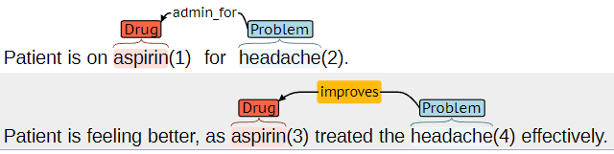

**Figure 9. Annotation example where multiple drug-problem relations describing the same drug disposition multiple times in separate sentences. It is sufficient to annotate the relations within the sentence (closest).**

The Drug must be actually provided presently, or in the past. Hypothetical drug will not be included in relations except admin_for (but will be annotated as a Drug entity). For example,

**BRAT examples:**

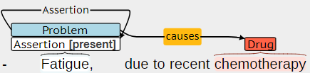

**Figure 10. Annotation example where Drug *causes Problem* (*causes*).**

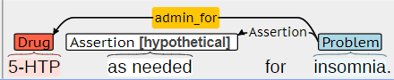

**Figure 11. Annotation example where *Drug is administered* for *Problem* (*admin_for*).**

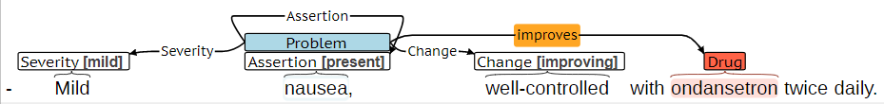

**Figure 12. Annotation example where *Drug improves Problem* (*improves*).**

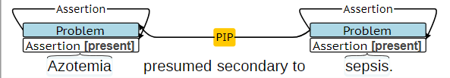

**Figure 13. Annotation example where *Problem Indicates Problem* (*PIP*).**

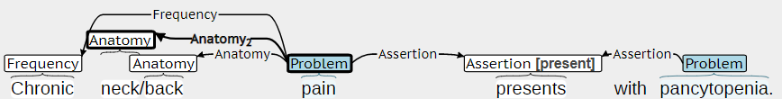

**Figure 14. Annotation example where multiple problems co-occur, without explicit *Problem Indicates Problem* (*PIP*) relationship.**

**Indirect “Cause” relation between decrease functionality and enzalutamide, shouldn’t be annotated**

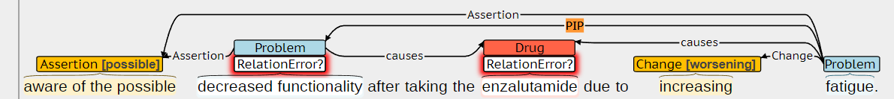

**-> corrected, Spencer/Relation/check_4021876084**

# Defining Events

**Intra-sentence annotation:** Each trigger span defines a new event. In most cases, the description of each event, specifically the trigger and arguments, will be confined to a single sentence. To the degree possible, an event should be confined to a single sentence. If the event trigger is defined in the current sentence, *si*, the event may include arguments from the preceding sentence, *si-1,* or the subsequent sentence, *si+1*, if necessary. However, arguments should not be annotated in sentences beyond the immediately preceding or subsequent sentences (i.e. no arguments in *si-2*, *s1+2*, etc.).

**Minimum annotation:** Events should only be annotated, if all required arguments can be identified. For example, a problem event should only be created if both the *Trigger* and *Assertion* are present.

## (1) spert PREANNOTATION.

Please check and correct pre-annotations, and link the trigger-attributes. Below are some common mistakes for the pre-annotation:

1. Problem trigger outside the guideline definition.

-> the first Polypharmacy is the header. The confusion is not a medical problem.

2. Missing infrequent spans. (like the “*Change[no_change]*” below)



->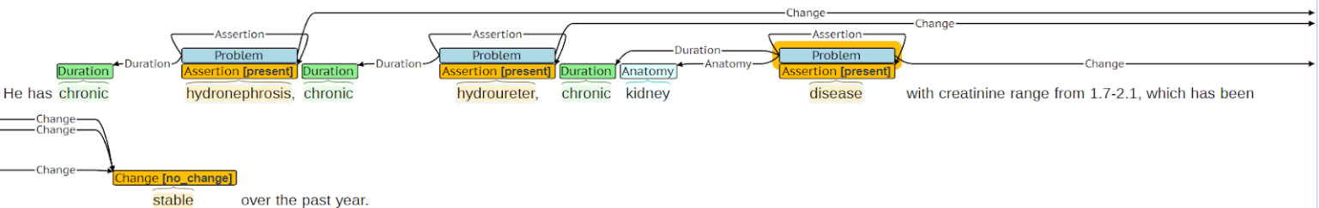

3. Overlap spans - only keep one for the same type

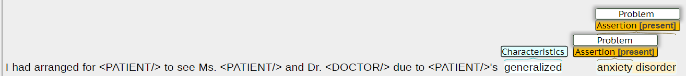 ->



1. Missing assertion labels

->

## Appendix

|  |
| --- |
| **Examples** |
| HPI: <AGE/>yo with hx HTN, AF with RVR who p/w nausea and dizziness.  Per ED and surgery notes, she developed nausea (but no vomiting), mild abdominal pain, and some diarrhea.  hpi: the patient had 1 week history of fever/chills, upper respiratory symptoms.  HPI: 34F w/ Crohn's disease on Imuran reported flu-like fever, headache, myalgia, sore throat on [**DATE**].  The patient had fever, cough, SOB x 3 days prior to admission.  Per HPI. Lower back pain leaving him unable to move for days at a time.  Patient has had chronic dry cough but has experienced clear sputum production since yesterday.  (+) Per HPI, also reports occasional HA and back pain, and ? some recent wt gain, endorses occ DOE.  …black stools…  …neck/back pain…  …had been sick…  … discomfort radiated to arm…  patient… was forgetting the details of…  patient… was … confused  … consistently confused at rehab.  … but confabulates a story…  … that he couldn’t feel or move his legs…  … feels her breathing is slightly improved…  … due to his continued bruising.  … thought was constipation.  … became unresponsive…  …did not have any loss of sensory or motor function.  … no numbness or weakness.  …with treatment for sinusitis…  …was found rigoring but with…  SOB Date : 3 / 30 / 2020 ; …  Diagnosis : Dyspnea  No rales / wheezes / rhonchi .  SKIN : RUE swelling , no rashes , R great toe with discoloration  Over the next few days she started developing chest heaviness with negative chest pain work up .  She has fibromyalgia and chronic fatigue .  On presentation to the emergency department she was tachypnic and ill - appearing .  [ ] Cough [ ] Fever ( … ) [ ] Shortness of breath [ ] Myalgias [ x ] Sore throat [ ] None of these  Suicidal without plan …  Not following commands or answering to voice .  Crying initially due to stress .  Patient unable to communicate and provide ROS  Psych : Irritable , but answering questions appropriately  …no confusion or short term memory deficits…  GENERAL : Disheveled young man resting in chair nodding off  She says " I have never been this dehydrated before “  h / o heart failure but has not urinated since midnight (over 9 hrs ) .  Alcohol - ~4 beers / d denies any hx of withdrawal symptoms  Withdrawal seizures a possibility |

**Table A. Problem Trigger annotation examples. Underlined words indicate the identified span.**